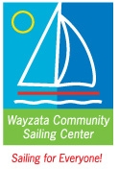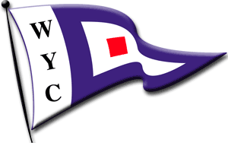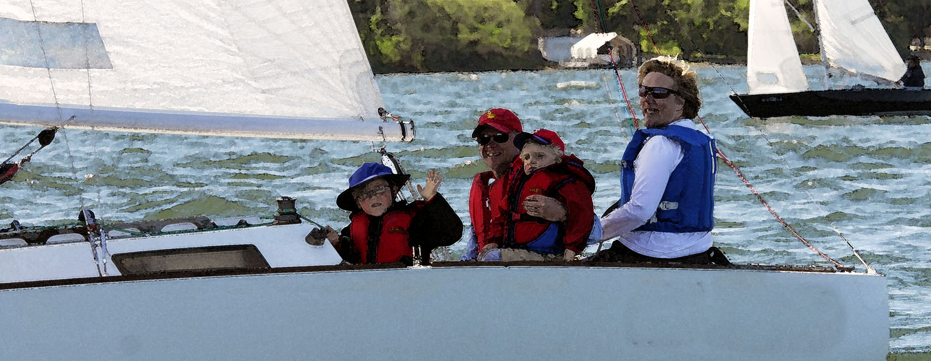
Wayzata Community Sailing Center/ Wayzata Yacht Club
Bob Slocum Memorial Family Regatta and Picnic

Saturday June 15, 2013, 10 am to naptime…

A short (45-minute) race.
A family event welcoming all ages, and an opportunity to host friends or novice sailors.
A chance to honor Sailor Bob Slocum and support the Wayzata Community Sailing Center.

Tons of Prizes
Traditional “Best to Finish” racing scored by WYC class
Other special categories to be determined!

Picnic at WYC follows races and includes family games and Ice Cream Sundae Bar!

$5/person SUGGESTED DONATION TO WAYZATA COMMUNITY SAILING CENTER
Register on the day, let us know you’re coming if you can.
Bring your sailboat if you have one.
Don't have a boat and want to sail? We'll find a boat for you.
Contact: Heather Fraser, heatherf@pcspeed.com 612-715-0054

What to expect at the Family Regatta

- Figure on 10 am-2 pm to include the race and the picnic
- Dress for a cool day at the beach
- There is no WYC dress code—no need for anything other than what’s sporty and comfortable!
- Try to wear shoes that are grippy and won’t leave scuff marks on the boats (light colored soles rather than dark)
- Kids need lifejackets (adults recommended). Please bring them if you have some.
- Try to bring a windbreaker, a small water bottle and maybe a small snack—like crackers or a granola bar just in case
- There will be a short registration form to fill out when you get to the club
- Once we get through the race, there will be lots of opportunity to help out and to relax—feel free to take advantage of both
- One thing to keep in mind is that safety is important—if your kids or someone else’s kids are doing something that you don’t think is safe, speak up! Most boating kids have been drilled about safety, but sometimes they need a reminder, and some kids might not know what’s safe and what isn’t. Better safe than sorry!

