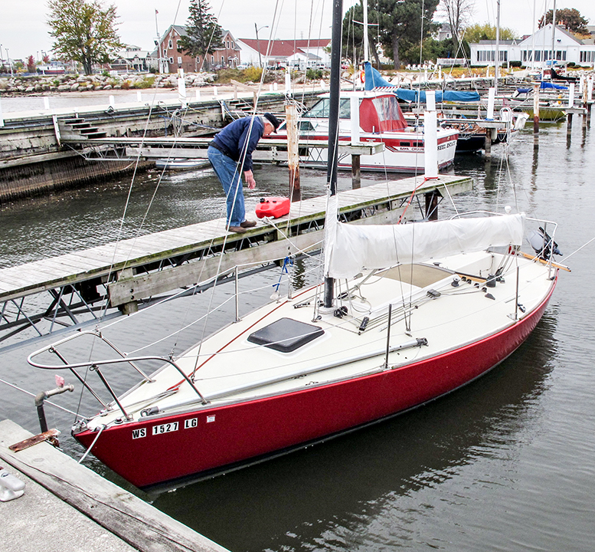
J/24 With Trailer
For Sale $5,000 as is
Single-owner boat in possession since 1980 – Sheboygan, WI Yacht Club
Complete with:
- Sails: Main, 100%, 150%, 170%, two spinnakers
- GPS with Lake Michigan chip
- Ship-to-shore radio
- Depth sounder
- Galvanized Triad trailer with spare tire
- Running rigging
- Heavy Danforth Anchor with heavy line and chain rode
- Winter Storage PVC-tube frame
- 12/V Battery
- 8 HP Yamaha motor w/alternator and gas tank
- Bunk cushions
- Dock lines
Contact Phil or Audrey Waitkus 920-627-0081 or 920-627-0080

