J/70 Mast Conversion Kit
Southern Spars closed their spar facility in Sri Lanka in early 2019 and then moved their after-market, small parts production for the J/70 and other classes to Valencia, Spain where they continued to supply spreader brackets and spreaders. This continued until last Fall when the small parts work was phased out. In support of the many J/70s equipped with Southern Spars, we recently confirmed arrangements with Southern to ship their J/70 small parts patterns to the USA, and we are now in the process of setting up new suppliers. In the meantime, we recently developed a new J/70 Mast Base Conversion kit that combines a modified Selden step (that fits the same hole pattern as the Southern step) with a custom-machined composite plug to fit the Southern mast tube. The kit was developed as an after-market solution for mast bases/spars with excessive corrosion, but not enough to warranty spar replacement.
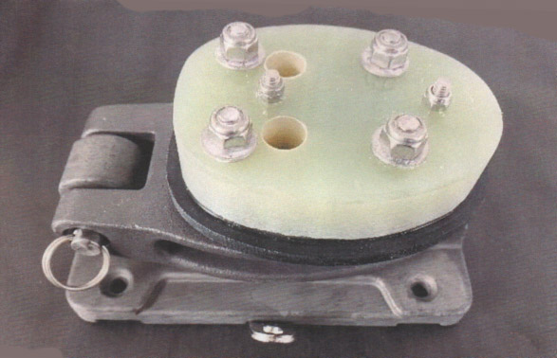
J/70 MAST BASE CONVERSION KIT DETAILS:
The J/70 Mast Base Conversion Kit is comprised of a modified Selden step and base plate coupled with a custom-machined, two-part composite plug to fit the Southern mast tube. The mounting holes for the new step match up with the original Southern mast step. Whether you are rectifying a corrosion issue that’s developed at the bottom of your Southern mast, or you are simply upgrading to take advantage of the better vertical clearance (when lowering the mast) above the molded companionway coaming, this conversion kit is a suitable option. Please note that to maintain the same rig height between old and new step, the bottom of the Southern mast must be trimmed 25mm before being fitted with the new base assembly. If converted precisely, your current rig settings will remain the same

Installation instructions below:
