The Star of the North Regatta will be recorded via the raceQs (www.raceQs.com) sailing app. We are asking all boats to participate as an interactive way of sharing this event with spectators and other sailing enthusiasts.

Races will be replayed in the WYC club house following each day’s races. The regatta can be accessed live (5 min time delay) or replayed from our Star of the North raceQs link: http://raceqs.com/regattas/58047

GETTING STARTED

- DOWNLOAD IT
Download the free raceQs app onto your Android or iPhone.
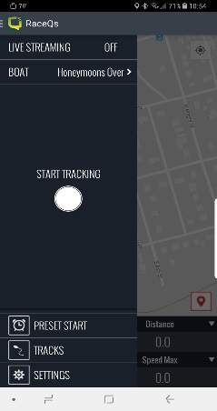

Live Broadcast toggle. Make sure your phone is plugged into external power.

- GO Race
Push one button and raceQs will record everything you need.
Registration is not required to utilize the app for the regatta.

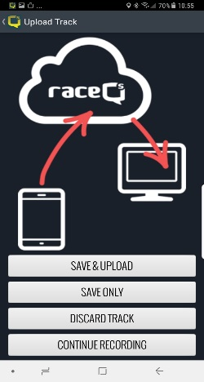

- UPLOAD IT
Broadcast your track LIVE or upload it via wi-fi/cellular after the race.

- WATCH IT
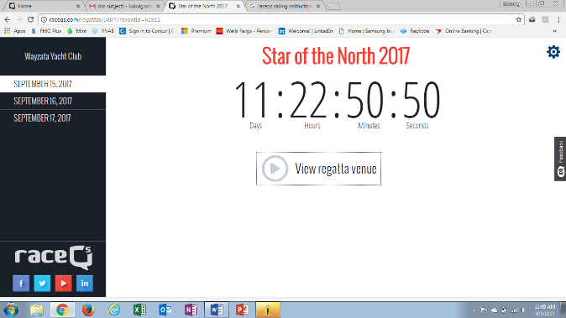
The Start of the North live broadcast page: http://raceqs.com/regattas/58047
Or login on your computer to raceQs.com to view, edit and share your 3D race replay.

FAQ

Do I need cell phone coverage for the phone app to work?
No cell phone or internet coverage is not required for regatta tracking, although you need it for a live broadcast. Just record your race with the phone app, and upload it later.

Will the app work down below?
Yes. Your phone GPS will still work through most sailboat decks.

What is the best way to position my phone?
Your phone running raceQs should be level and oriented in line with the centerline of your boat. Place or mount it so that it does not slide around during the race. DO NOT keep your phone in your pocket. This will cause very erratic tracking.

How will raceQs effect my battery?
You can run raceQs in live broadcast or offline mode. Live Broadcast will use up your battery in about 1 race unless plugged into an external power source. Offline mode will make your battery last much longer but a backup battery, etc. is highly recommended.

Do I need to stop and start the app between the races?
No, unless you want to save battery life. We can easily segment the races afterward in raceQs.

Will the app track me all the way home and publish my location online?
If you forget to shut off your app, we designed a failsafe that will shut off tracking once you reach a certain speed in your car.

How do I watch the replay?
You can watch the replay two ways.
- Star of the North Regatta link: http://raceqs.com/regattas/58047
- Your raceQs account at www.raceqs.com.

Need extra help?
Ludwig von Gohren #229 Honeymoons Over is our raceQs expert. C-Dock on the left before turn.

